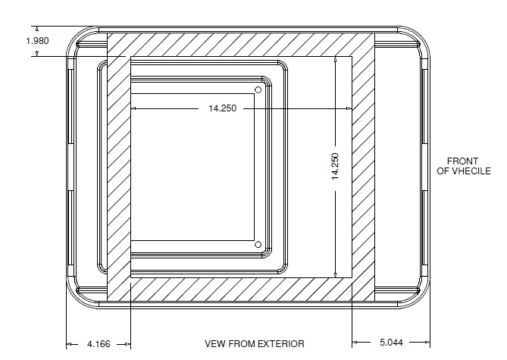
1. | Cut opening in roof. Use supplied drawing (example above) as reference for size and placement.
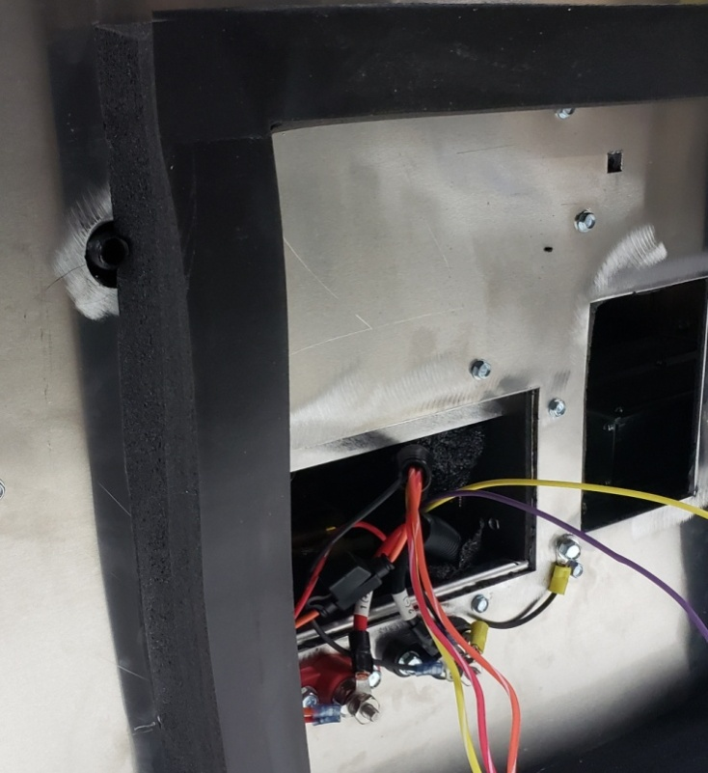
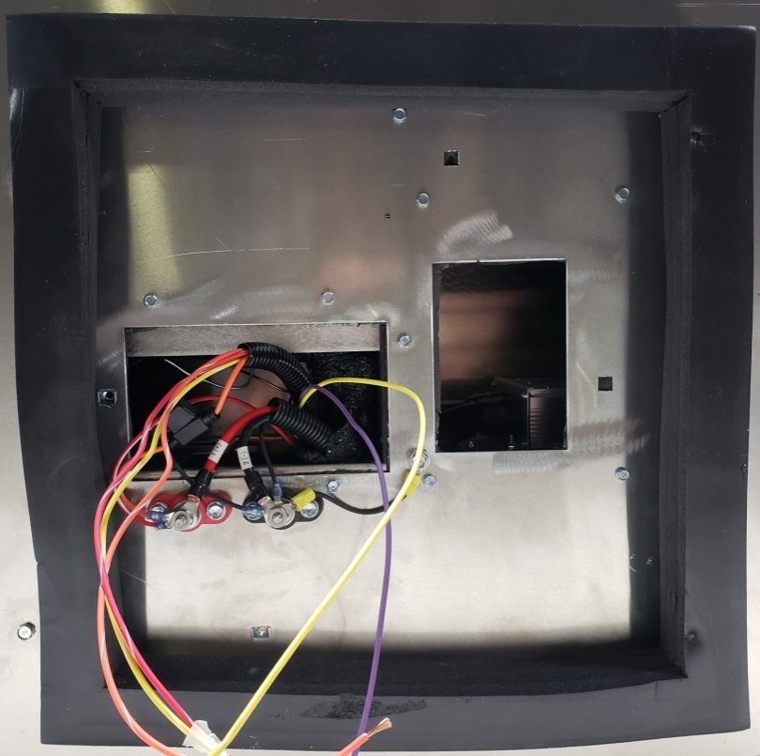
3.
A
Fig. 2
Fig. 1
2. | Attach main gasket. Be sure to place gasket clear of the 4 cage nuts. Place rear of gasket as close as possible to cage nut (A). Fig. 1  *NOTE*: Route gasket around drain nipple. Fig. 2

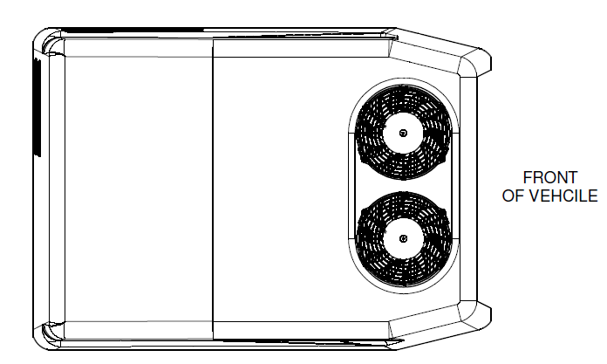
Fig. 3
3. | With hole cut and main gasket installed, set TurboAir2 unit in place. Fig. 3  *NOTE*: Fans must be facing front of vehicle.
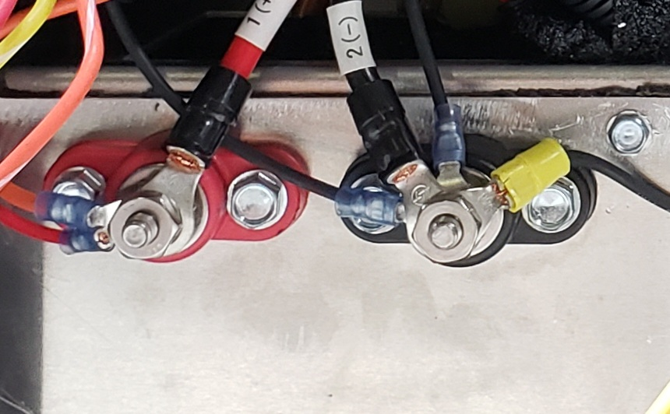
Fig. 4
4. | Connect main power and ground. Fig. 4
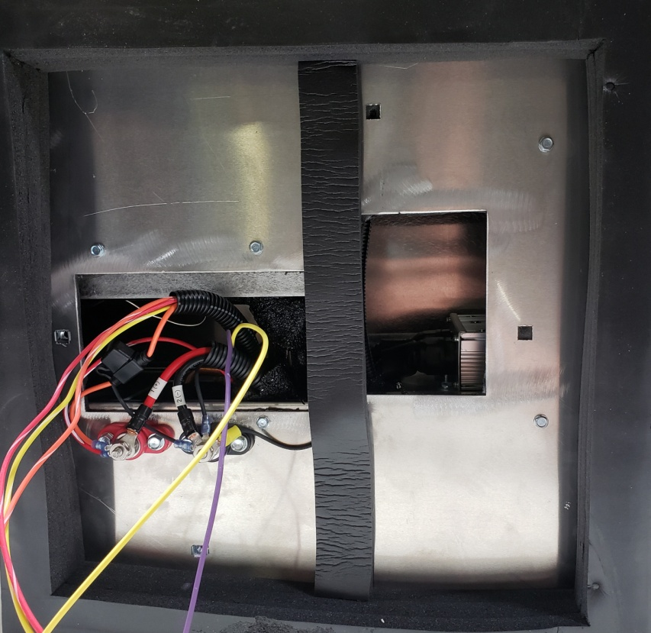
Fig. 5
5. | Attach intake seal to base of unit. Fig. 5  *NOTE*: Stack intake seal to appropriate thickness. Intake seal must make contact to interior mount plate.
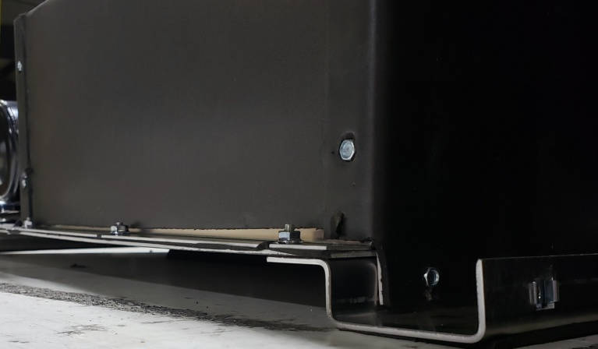
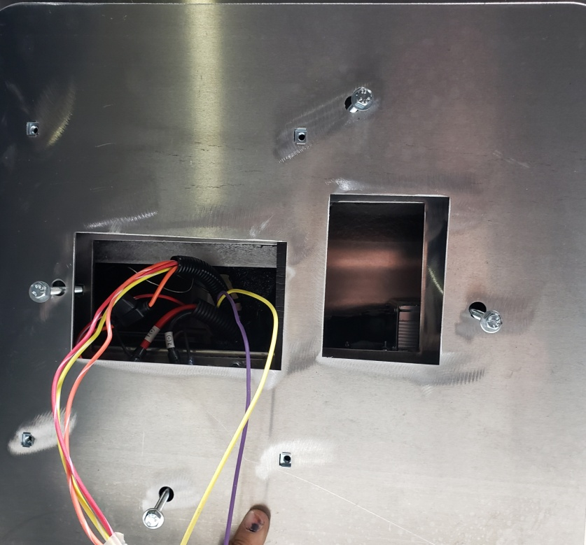
Fig. 7
Fig. 6
6. | Attach interior mount plate using supplied hardware. Fig. 6  NOTE: DO NOT over torque fasteners. Spacing between vehicle roof and bottom of unit should be uniform. Roughly 1". Fig. 7
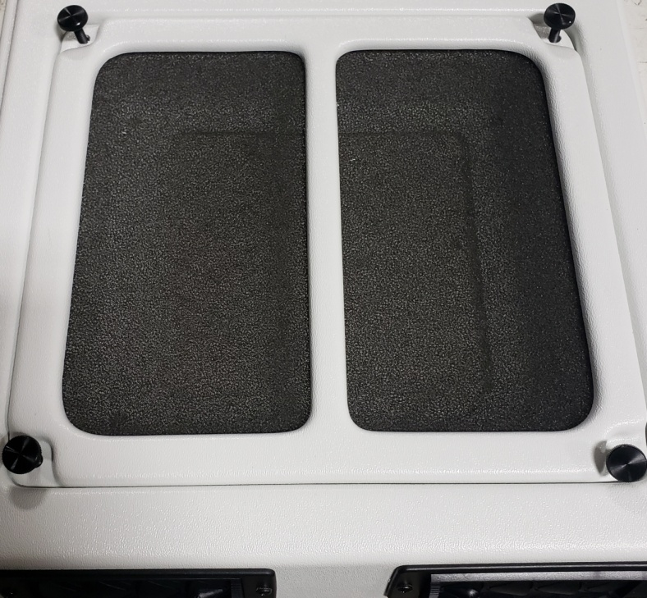
Fig. 8
7. | Loosen thumbscrews and set filter and filter cover to the side. Fig. 8
8. | Wire unit to controller option (instructions separate).
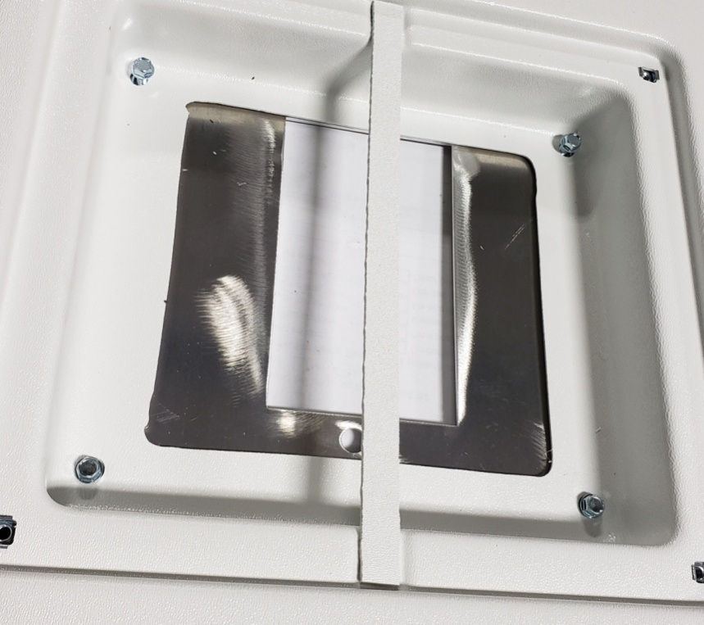
Fig. 9
9. | Attach plenum to ceiling plate using supplied hardware. Fig. 9
10. | Reattach filter and filter cover using thumbscrews from Step 7.

